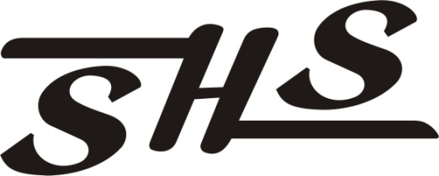WRESTLING
2022-2023
DAY | DATE | OPPONENT / EVENT | SITE | LEVEL | START TIME
SAT | NOV 12 | RIO VISTA SCRIMMAGE | RIO VISTA HS | ALL | TBA
SAT | NOV 19 | INTRASQUAD DUAL | SHELDON HS | ALL | TBA
SAT | NOV 26 | REDWOOD RUMBLE  BUDDYS BEAR BASH  GODDESS OF WAR | REDWOOD HS  MERCED HS  TOKAY HS | V  JV  GIRLS | TBA  TBA  TBA
SAT | DEC 3 | VISTA VARSITY INVITE  FOLSOM JV  CASA ROBLE INVITE | VISTA DEL LAGO HS  FOLSOM HS  CASA ROBLE HS | V  JV  GIRLS | TBA  TBA  TBA
SAT | DEC 10 | CURT METTLER  SMEDBERG INVITE | ELK GROVE HS  SMEDBERG MS | V  JV, GIRLS | TBA
SAT | DEC 17 | MARTY MANGES  MEL FOCHA | CASA ROBLES HS  ESCALON HS | V  JV, GIRLS | TBA  TBA
WED | DEC 28 | BRITTANY DAVID | LIBERTY HS | GIRLS | TBA
THU | DEC 29 | NO GUTS, NO GLORY | TBA | V, JV | TBA
FRI  SAT | JAN 6  JAN 7 | LLOYD C ENGEL  NAPA VALLEY CLASSIC | ESCALON HS  VINTAGE HS | V  GIRLS | TBA  TBA
TUE | JAN 10 | CO & PG | ELK GROVE HS | V, JV | 5:00 PM
FRI  SAT | JAN 13  JAN 14 | TIM BROWN  MARK FULLER  LADY ZEBRA | MEMORIAL AUDITORIUM  LINCOLN HS  LINCOLN HS | V  JV  GIRLS | TBA  TBA  TBA
TUE | JAN 17 | DAVIS & JESUIT | SHELDON HS | V, JV | 5:00PM
SAT | JAN 21 | PITMAN RUMBLE  JV WRESTLING CHAMP  LADY EAGLE INVITE | PITMAN HS  DEL ORO HS  DEL ORO HS | V  JV  GIRL | TBA  TBA  TBA
TUE | JAN 24 | EG & FRANKLIN | FRANKLIN HS | V, JV | 5:00PM
SAT | JAN 28 | SECTION TEAM CHAMPSIONSHIPS | LINCOLN HS | V | TBA
SAT | FEB 4 | DELTA LEAGUE | PLEASANT GROVE HS | V, JV,  GIRLS | TBA  TBA
FRI  SAT | FEB 10  FEB 11 | DIVISIONALS | TBA | V | TBA
FRI  SAT | FEB 17  FEB 18 | SJS MASTERS | STOCKTON ARENA | V | TBA
THU-  SAT | FEB 23  FEB 25 | CIF STATE MEET | RABOBANK ARENA | V | TBA
GIRLS POSTSEASON
FRI  SAT | FEB 10  FEB 11 | NORTH REGIONAL | NATOMAS HS | GIRLS | TBA
FRI-SAT | FEB 17  FEB 18 | SJS MASTERS | STOCKTON ARENA | GIRLS | TBA
THU-SAT | FEB 23  FEB 25 | CIF STATE MEET | RABOBANK ARENA | GIRLS | TBA

